Name___________________________________

Quick Quiz

**Unit Rate 11**

Identify the unit rate:

1. $36 for 4 basketballs 2. $y=8x$

**$_________ per basketball unit rate =_________**

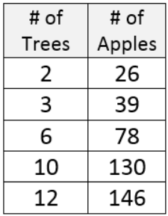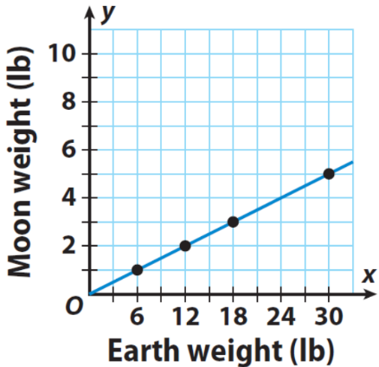3. 4.

**________ _______**

**apples per pounds on Earth**

**tree per pound on**

**the moon**

____________________________________________________________________________

Corrections

**Unit Rate 11**

Identify the unit rate:

1. $36 for 4 basketballs 2.

**$_________ per basketball unit rate =_________**

3. 4.

**________ _______**

**apples per pounds on Earth**

**tree per pound on**

**the moon**